Note: Include this page only when adding / amending / deleting a document. If using this document as a record, this Revision History page can be omitted.

REVISION HISTORY

Revision no | Date | Description of Changes | Reason for Revision | Revised by | Approved by
00 | Mar. 14, 2014 | Initial document | To simplify BDM’s process | RDPlacido
01 | Apr. 8, 2016 | Added disclaimer when printing the document | For document control | RCGanal | RTMonzon
TM-BR-MG- 11 Rev02, 10302015

- Objective:

To generate leads through effective planning and execution of marketing strategies such as Email Marketing, Press Release, Events Management and Telemarketing.

- Scope:

This procedure defines the actions & responsibilities of the Marketing Assistant in planning and executing marketing campaigns.

This covers the following activities:
- Email Marketing
- Press Release
- Events Management
- Telemarketing

- Definition of Terms:

None

- Procedure Details

RESPONSIBLE | ACTIVITY | INTERFACE
Marketing Assistant | 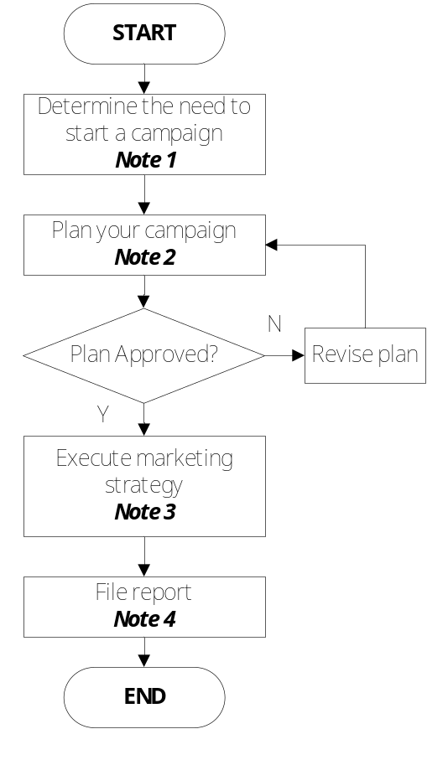 | ExeCom  Concerned Units  Campaign Plan & Report/  Event Plan & report  ExeCom  Campaign Plan & Report/  Event Plan & report

Notes:
- Campaigns may be required for a variety of reasons such as:
  - Lead generation
  - New training offerings
  - Corporate news
  - Plans for events
  - Available developers on pool
  - Promotion / discounts

There must be at least 1 email blast per month.

- Use the Campaign Plan and Report Template. If you are planning for an event, directly use the Event Plan & Report Template.
- Use designated supporting documents assigned per marketing strategy
  - Email Marketing
    - Email Marketing Guideline
    - Post Email Campaign Report
  - Press Release
    - Press Release Guideline
    - Press Release Template
    - Press Release Filing Guide
  - Events Management
    - Events Management Guideline
    - Event Plan & Report Template
  - Telemarketing
    - Guidelines for Telemarketing
- Use the Campaign Plan and Report Template. Include this in the KPM Monitoring Report.

- References

- Campaign Plan and Report
- Email Marketing Guideline
- Post Email Campaign Report
- Press Release Guideline
- Press Release Template
- Press Release Filing Guide
- Events Management Guideline
- Event Plan & Report Template
- Telemarketing Guideline
- Quality Records

- Campaign Plan and Report
- Post Email Campaign Report
- Press Release
- Event Plan & Report

